Vijaykumar R Pai

PES1201702013

1. hive> create database moviedetail;

hive> use moviedetail;

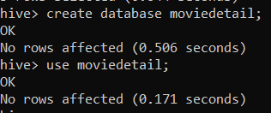

1. hive> create table movies (

. . > id bigint,

. . > title string,

. . > genres string

. . > )

. . > row format delimited fields terminated by ‘,’

. . > location ‘/movies’;

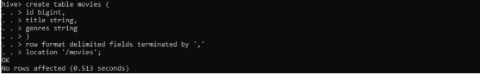

hive> create table ratings (

. . > user_id bigint,

. . > movie_id bigint,

. . > ratings bigint,

. . > time bigint

. . > )

. . > row format delimited fields terminated by ‘,’

. . > location ‘/ratings’;

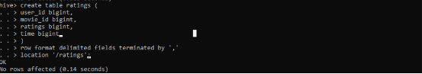

1. hive> select * from movies limit 20;

hive> select * from ratings limit 20;



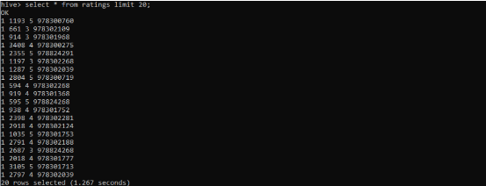

1. hive> select count(*) from users where age < 18;

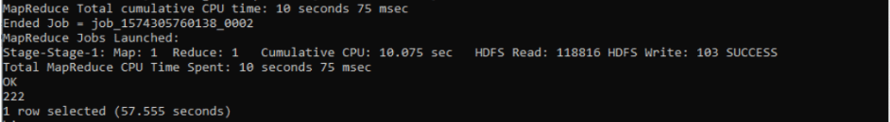

1. hive> select u.user_id, u.age, x.count from users u join (select r.user_id, count(rating) count from rating r group by (r.user_id) order by count DESC limit 1) x where u.user_id = x.user_id;

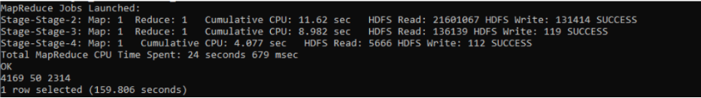

1. hive> select count(r.ratings) from ratings r, users u where u.id = r.user_id group by u.age;



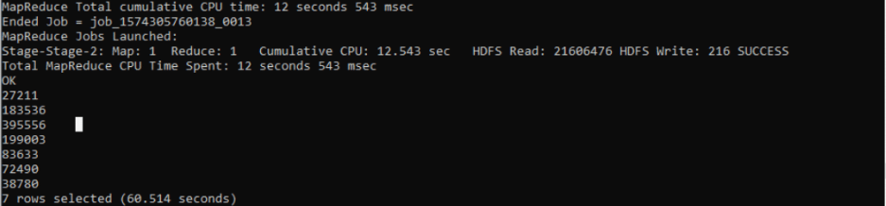

1. hive> select count(r.ratings) from movies m, ratings r where m.id = r.movie_id;



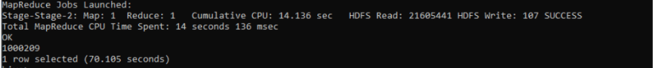

1. hive> select count(r.ratings) from movies m, ratings r where m.id = r.movie_id and r.ratings = 1;



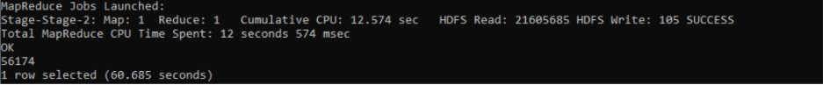

1. -
2. hive> create database userdetails;

hive> use userdetails;

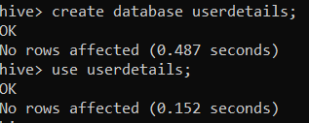

1. hive> create table users (

. . > id bigint,

. . > gender string,

. . > age bigint,

. . > occupation bigint,

. . > zip bigint

. . > )

. . > row format delimited fields terminated by ‘,’

. . > location ‘/users;

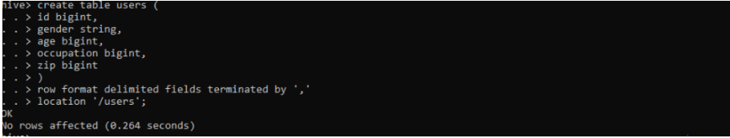

hive> create table occupation (

. . > id bigint,

. . > occupation string

. . > )

. . > row format delimited fields terminated by ‘,’

. . > location ‘/occupation;



1. hive> select u.*, o.occupation from users u, occupation o where u.occupation = o.id limit 10;



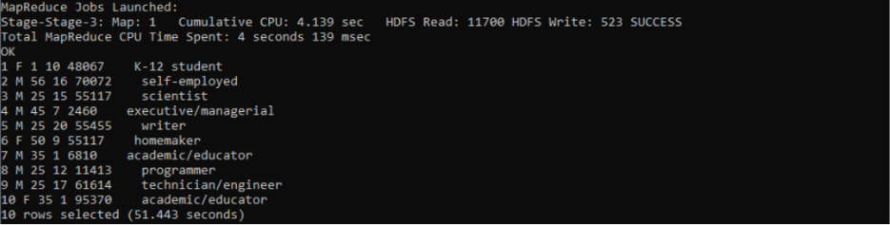

1. hive> select o.occupation, count(1) from users u join occupations o where u.occupation_id = o.id AND u.age > 24 group by o.occupation;



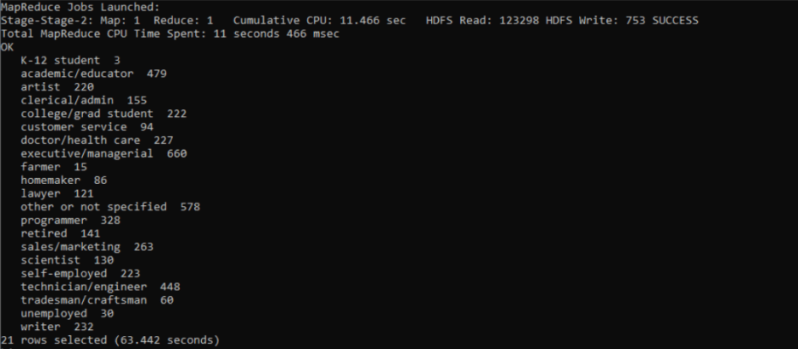

1. hive> select u.*, o.occupation from users u, occupation o where u.occupation = o.id AND u.gender = ‘F’ limit 10;



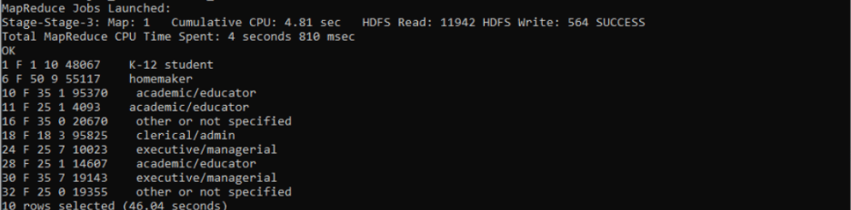

1. hive> select count(*) from users u, occupation o where u.occupation = o.id and o.occupation = ‘ doctor/health care’;



